5 marker questions

1. 0.75 gram of petroleum was burnt in a bomb calorimeter which contains 2kg of water equivalent 500 gram. The rise in the temperature was 30C. The calorific value of petroleum is 10nN. What is the value of n?

ANSWER: 4

1. Two spherical bodies A (radius of 6 cm) and B (radius 18cm) are at temperatures T1 and T2 respectively. The maximum intensity in the emission spectrum of A is at 500nm and in B is 1500nm. Considering them to be black bodies, what will be the ratio of the rate of total energy radiated by A to that of B?

ANSWER: 9

1. On your visit to Stonehenge u found an ancient code of numbers. Decode the code (73,84,67,88,71,91,67,84,70) if 'DEMISE' is (70,71,79,75,85,71)

ANSWER: GRAVEYARD

1. Being an engineer, a structural engineer consulted you to help out with a technical trouble he was facing. Find the position of the centroid of the given figure about AB. Take A as the origin. Answer in the format <X>,<Y>

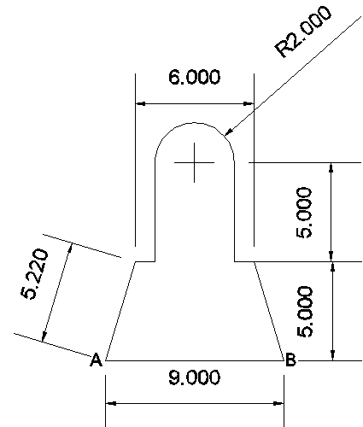

ANSWER: X=4.5, Y=4.79

1. On your way to 30 St. Mary Axe you passed by BIG BEN, you noticed that the time was 10:20, after visiting the 30 St Mary axe and now reaching the Big ben, you notice that the hour hand has moved by an angle 73 degrees .What is the time now? Answer in the format (hh:mm)

ANSWER: 12:46

1. A ship is sailing westwards at 8 m/s. While trying to fix a bolt at the top of the mast, the sailor drops the bolt. If the mast of the ship is 19.6 m high, where will the bolt hit the deck?

ANSWER: at its foot

1. A cart of mass 500 kg is standing at rest on the rails. A man weighing 70 kg and running parallel to the rail track with a velocity of 100 ms-1jumps on to the cart on approaching it. Find the velocity with which the cart will start moving?

ANSWER: 1.23m/s

1. A disc of mass 10g is kept floating horizontally by throwing 10 marbles per second against it from below. If the mass of each marble is 5g, what is the velocity with which the marbles are striking the disc (cm/s). Assume that the marbles strike the disc normally and rebound normally with the same speed.

ANSWER: 98cm/s

1. A rocket is fired vertically from the surface of mars with a speed of 2km/s. If 20% of its initial energy is lost due to martian atmosphere resistance, how far will the rocket go from the surface of mars before returning to it? Mass of mars= 6.4x1023 kg, radius of mars= 3395km, G=6.67x10-11Nm2/kg.

ANSWER: 495km

1. Acc.to Newton’s law of gravitation the force acting on two bodies of mass 1kg situated at a distance of 10^-9m. the Force will be equal to

Answer: zero

1. A thick uniform bar lies on a frictionless horizontal surface and is free to move in any way on the surface. Its mass is 0.16kg and length is 1.7 m. Two particles each of mass 0.8kg are moving on the same surface and towards the bar in the direction perpendicular to the bar, one with a velocity of 10m/s and other with velocity of 6m/s. If collision between the particles and the bar is completely inelastic, both particles strike with the bar simultaneously. What is the velocity of center of mass after collision?

ANSWER: 4m/s

1. A gas kept on a container of finite conductivity is suddenly compressed. The process
2. Must be very nearly adiabatic
3. Must be very nearly isothermal
4. May be very nearly adiabatic
5. May be very nearly isothemal

ANSWER: c and d

1. A point charge is brought to an electric field. The electric field at a nearby point
2. Will increase if the charge is positive
3. Will decrease if the charge is negative
4. May increase if the charge is positive
5. May decrease if the charge is negative

ANSWER: c and d

1. Two resistors having equal resistances are joined in series and a current is passed through the combination. Neglect any variation in resistance as the temperature changes. In a given time interval,
2. Equal amount of thermal energy must be produced in the resistors
3. Unequal amount of thermal energy may be produced
4. The temperature must rise equally in the resistors
5. The temperature may rise equally in the resistors

ANSWER: a and d

1. A planet of mass m is revolving around the sun in an elliptical orbit. If ‘v’ is the velocity of the planet when its position vector from sun r then if the planet rotates in counter clockwise direction then areal velocity has direction
2. Given by “ right hand thumb rule”
3. Given by “ left hand thumb rule”
4. Normal to the plane of the orbit upwards
5. Normal to the plane of the orbit downwards

ANSWER: a and c

1. When a body cools by radiation the rate of cooling depends upon ( mention 5)

Answer:

1. Temperature of radiating body
2. Temperature of surroundings
3. Mass of radiating body
4. Area of radiating surface
5. Nature of radiating surface
6. Specific heat of radiating body.
7. You need to fill number in the bricks in the image below such that the top brick is sum of two brick below it.

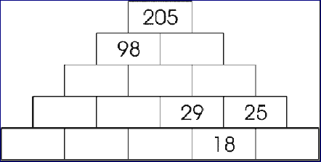

ANS:

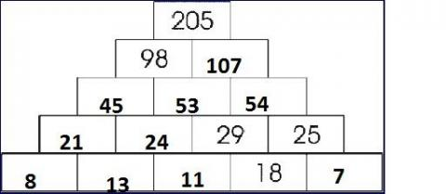

1. Select the correct option/ options
2. An object shall weigh the same at pole and equator when weighed by using a physical balance.
3. It shall weigh the same at pole and equator when weighed by using a physical balance.
4. It shall weigh the same at pole and equator when weighed by using a spring balance
5. It shall weigh the more at pole than at equator when weighed by using a spring balance.

Ans=b and d

1. Choose the wrong statements
2. Bulk modulas of elasticity is reciprocal of compressibility. (OPTION TO BE CHANGED)
3. The breaking force for a wire is F. The breaking force for a single wire of double thickness is 2F.
4. A wire stretches a certain amount under a load. If the load and the diameter of the given wire are both increased to three times , the stretch caused in the wire is 1/9 times.
5. The elastic after effect is negligible small for quartz but very large for glass fibre.
6. The possible value of Poissons ratio of a substance lies between 0 and 0.5.

Ans: b,c,e